**PRACTICAL – 2**

**AIM:**

|  |
| --- |
| **Store the data byte 32H into memory location 4000H.** |

**CODE:**

ORG 100H

MOV [4000H],32H

MOV AX,[4000H]

MOV [2000H],AX

RET

**OUTPUT:**

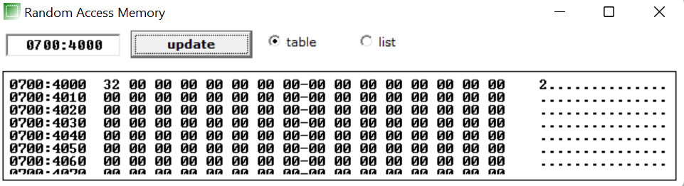

**CONCLUSION:** In this practical we learnt how to stored data byte in memory location.